**Major Project**

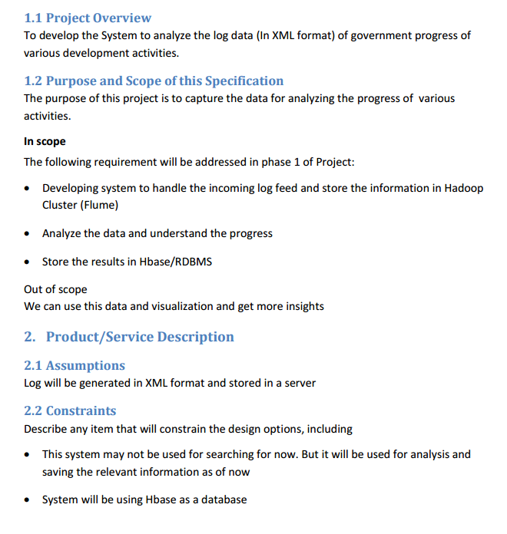

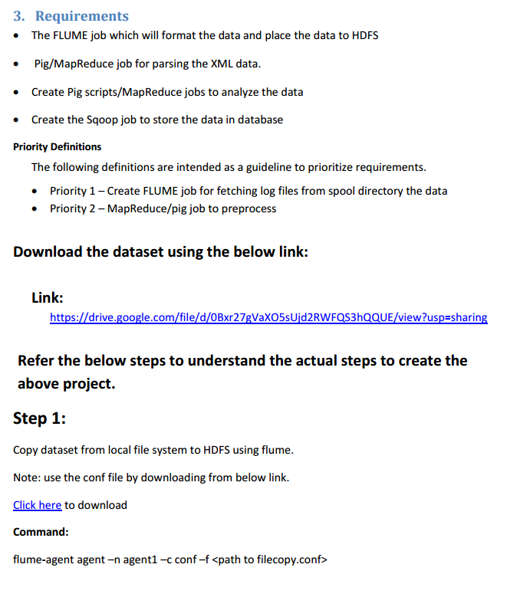

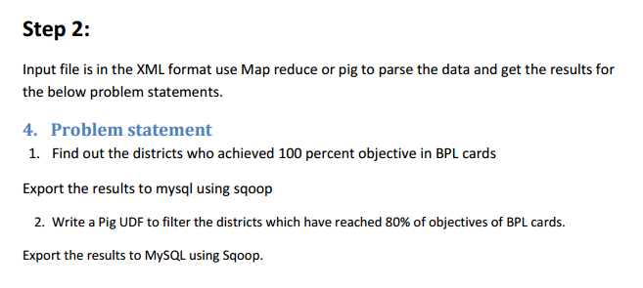

**SOLUTION:**

Copying dataset from local file system to HDFS using flume by using the below conf file.

**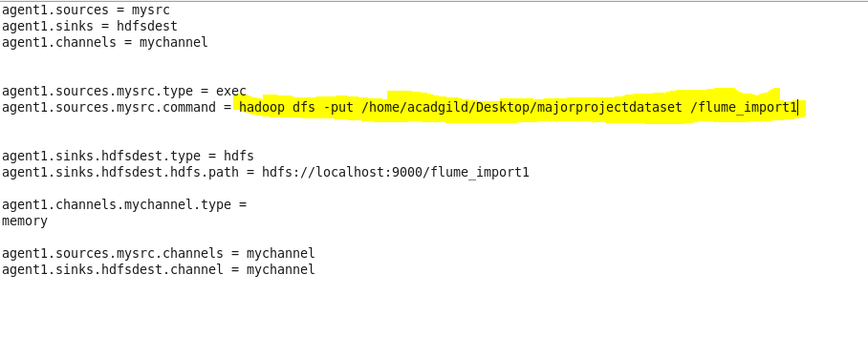**

Flume command to export data

**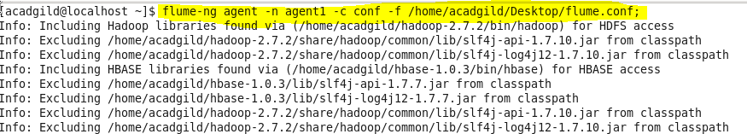**

**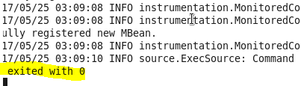**

**Listing the created directory and performing basic cat operation.**

**D:\majorproject\catflume_import1command.PNG**

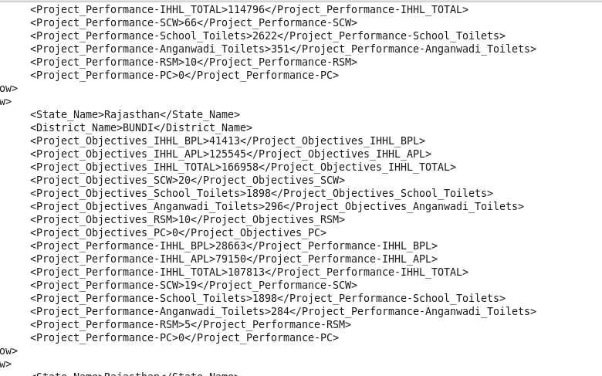

Here data is loaded from /flume\_import1 project location which contains a XML file and in order to parse the xml file so that Pig can understand it.

XMLLoader() function which is present in PiggyBank of Apache is used.



Using regex-function for capturing the values within tag and FLATTEN is used flattening the TUPLE.

D:\majorproject\pigcommand2.PNG

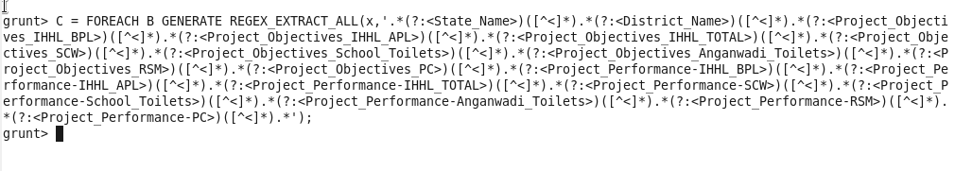

D:\majorproject\pigcommand4.PNG

**Storing the above results into HDFS for further analysis.**

D:\majorproject\pigcommand5.PNG

Here, we can see that data is successfully stored.

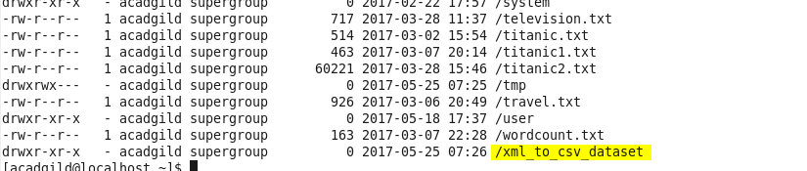

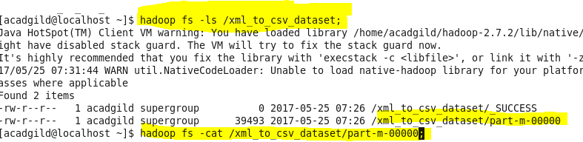

Using cat command we can see the stored data.

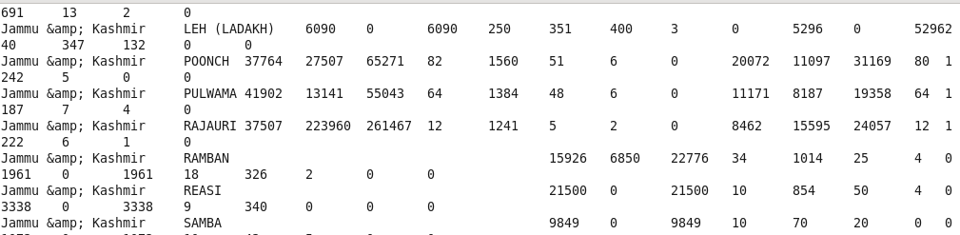

* **Find out the districts who achieved 100 percent objective in BPL cards Export the results to mysql using sqoop .**

Step1: loading the dataset

Step2: filtering the loaded data so as to get the districts who achieved 100 percent objective in BPL cards.

$10 is the project objective in BPL cards column

$2 is the project performance in BPL column

Comparing whether $10 i.e, project objectives in BPL have achieved 100 percent or not.

Step3: If achieved then generating $1 which is the district column

Step4: finally storing the results as OP1.

Running Pig:

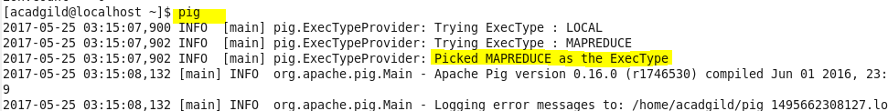

Loading dataset into pig:



Load output:

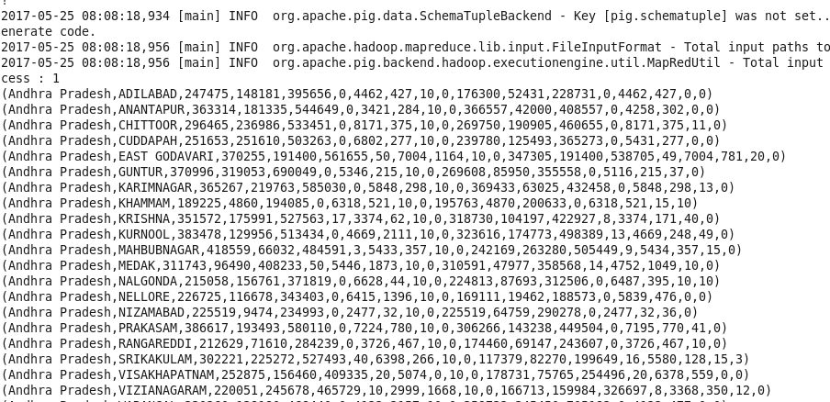

Running query to compare if project objectives have been reached by 100% or not:

D:\majorproject\generatingforquery1.PNG

Storing the result into hdfs:

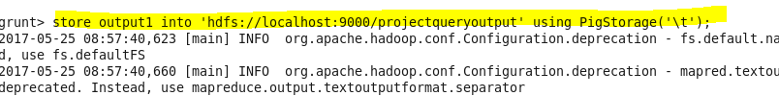

Here, we can see that job ran successfully. Then, using cat command displaying the results.

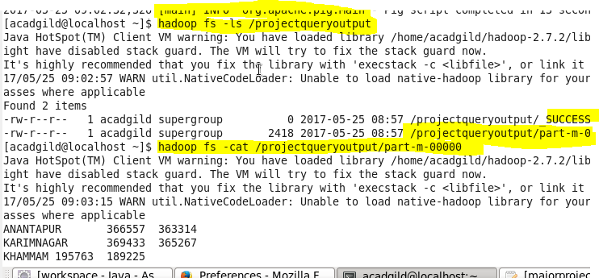

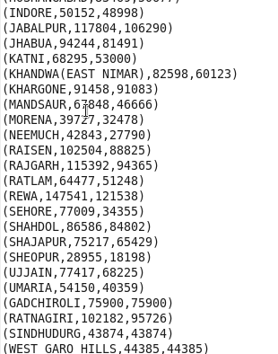

To export the result from pig using sqoop creating a table in mysql and inserting no values in the table so as to perform the export.

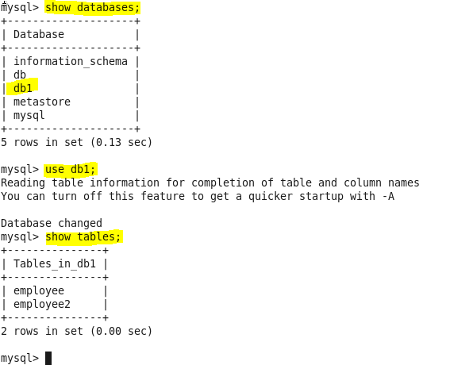

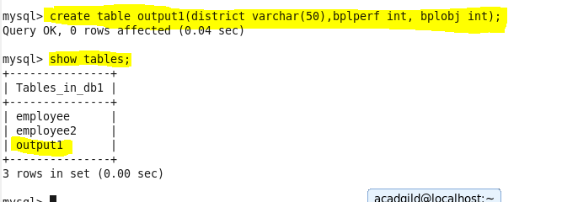

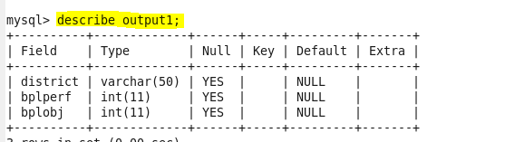

Below is the export command to export the records from pig to mysql

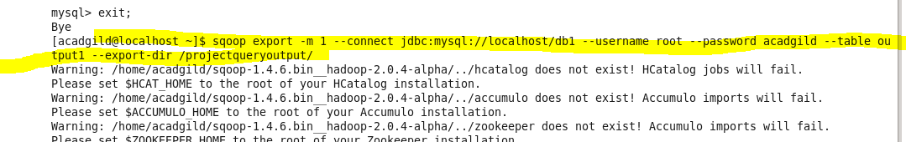

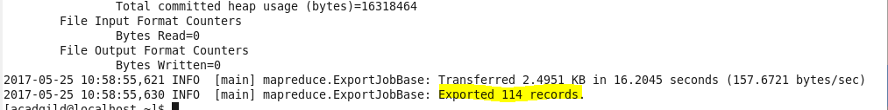

Here, we can see that the data is successfully exported.

Final output:

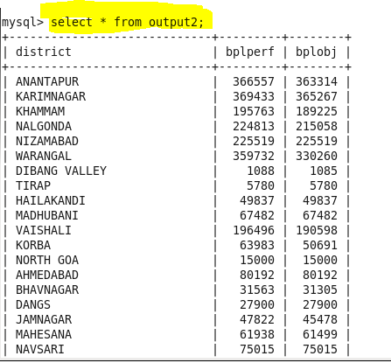

* **Write a Pig UDF to filter the districts which have reached 80% of objectives of BPL cards. Export the results to MySQL using Sqoop.**

**Creating UDF:**

Adding the necessary Imports

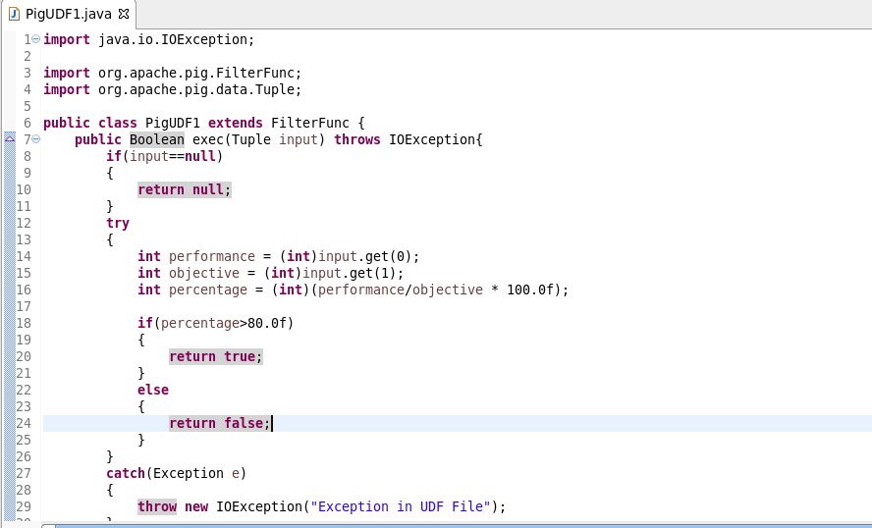

Firstly, registering the jar

Then, loading the data and the datatype and name of fields are defined.

**Filtering Districts that acheived 80%:**

Used a udf function “PigUDF1” that extends the filterfunc which filters the districts which have achieved less than 80%

**Generating District List:**

$1 is the district column. Here we are generating $1 so as to get the districts name which have reached 80% of objectives of BPL cards.

**Finally, Storing the result**

Data is stored into “que2op” in Hdfs from which it will be exported to mysql.

Piscript file:

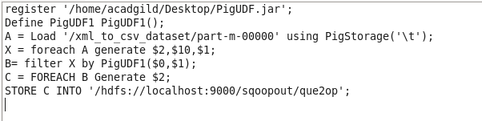

Running above pigscript:

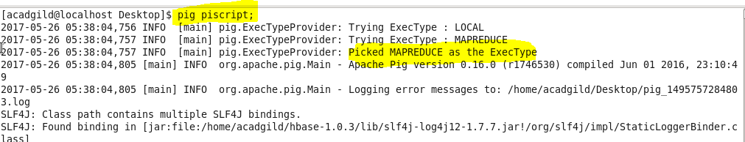

Listing it and then performing cat operation on it.

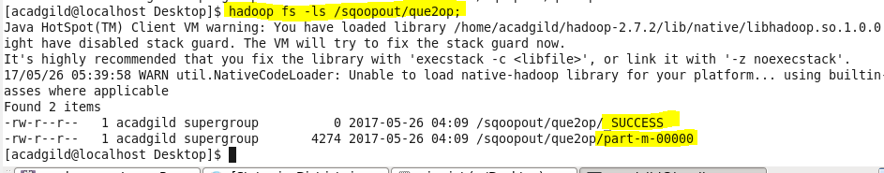

Cat command will display the stored output of the pig commands

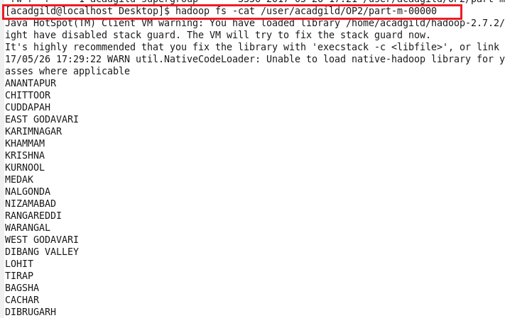

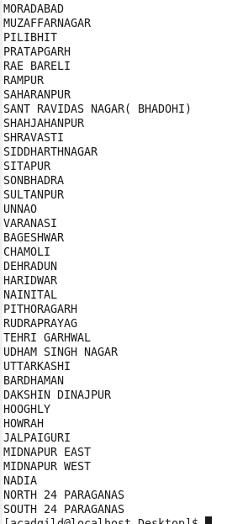

To export the result from pig to mysql using sqoop creating a table in mysql and inserting no values in the table so as to perform the export.

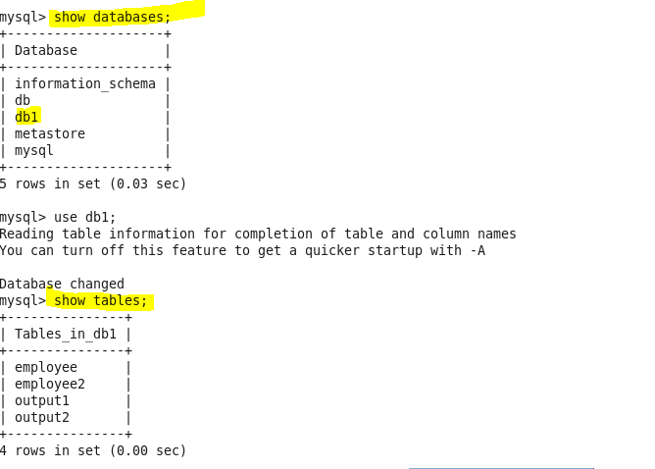

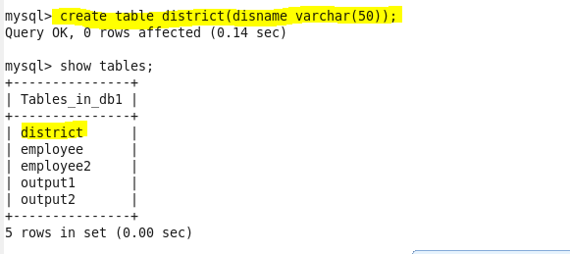

Below is the export command to perform export operation



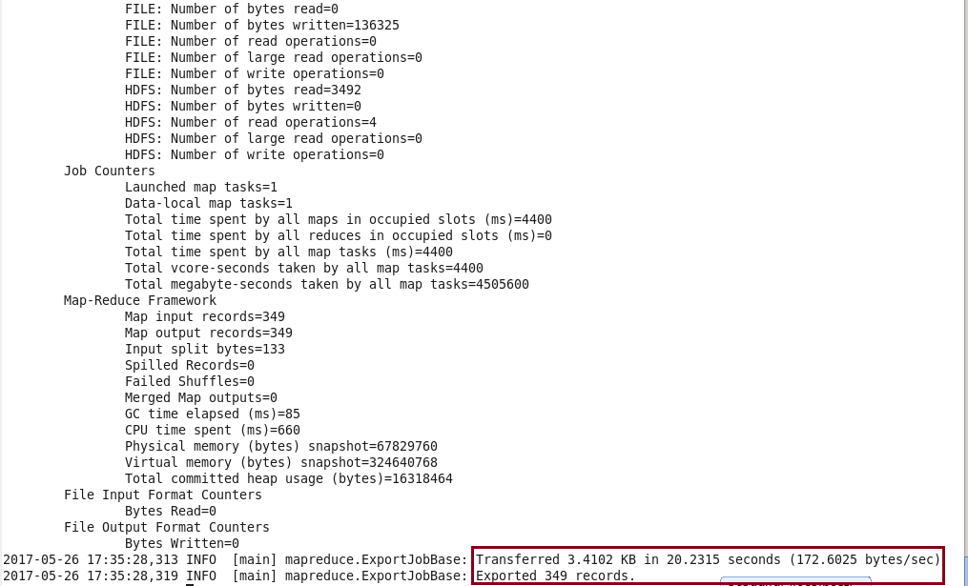

Here, we can see that successfully exported the records.

Using select command displaying the results.

